Directions to Access Assignments on Google Classroom at Home

- If you want to access Classroom, then go on the Internet and type in
classroom.google.com (make sure to spell it exactly as shown).
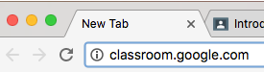

- When you are at the login screen, type in your email account name
(for example, s444444@brightenacademy.com).
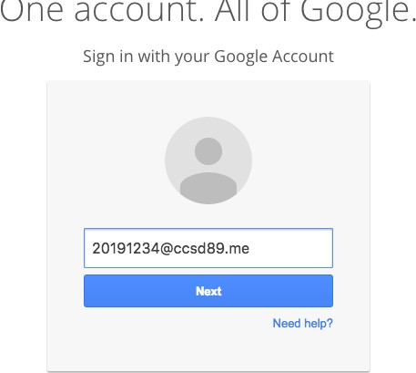
This is not your number. Type in your school email address and password.

*Note: If the sign-in box already has someone else’s gmail account in it
like the picture below, then click on “Sign in with a Different Account” and then click on “Add Account.”
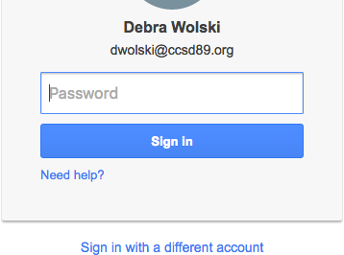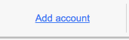

- Hit the “Next” button after typing in your email address.

- Type in your password

- Click on the “Sign In” button.

- Click on the name of your class.

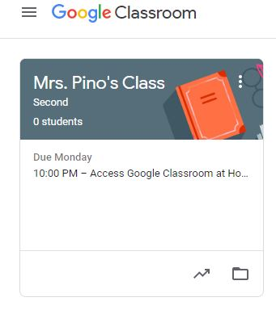

You are in!!

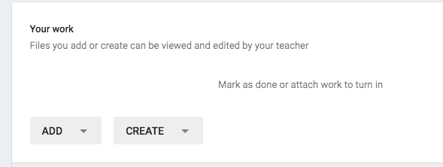
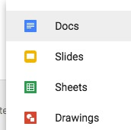
- If there is no link to click on to get to the assignment, click on “Create” and choose the type of assignment (Docs are for word processing like Microsoft Word. Slides are for a slideshow like PowerPoint. Sheets are for a spreadsheet like Microsoft Excel. Drawings are for diagrams and drawings.)
No link to an assignment.

- If there is a link to an assignment, click on the link to open your document.
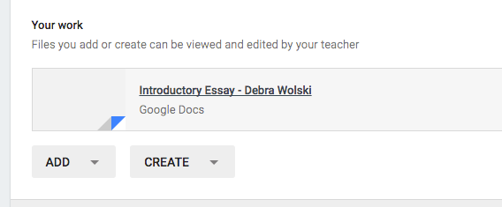
A link to an assignment.

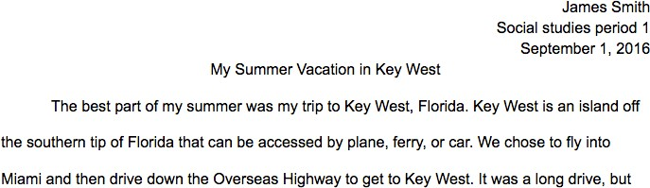
- Work on your assignment. Make sure you follow your teacher’s manuscript rules. For written papers, most teachers at Glen Crest will want you to have a 3-line heading at the top and a title that is centered below the title. The font should be a plain, regular font like Arial, Georgia, or Times New Roman. The size should be size 11 or 12 (no larger than size 12). The color should be black. Most teachers will want the paper double-spaced (8th grade wants the 3-line heading singles-spaced and the rest of the paper double-spaced). Paragraphs should be indented with a tab. The picture below shows what your paper may look like.

- Do a spell check to correct your spelling by pulling down the Tools menu→Spelling. Make sure you look it over for correct spelling and grammar as well because the Google Drive spell checker does not find all the errors.
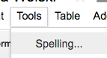
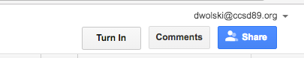
- When you are sure you are done, click on the Turn In button at the top right. Do not share the file with your teacher. You only share a document in Classroom with other students when you are doing group work.

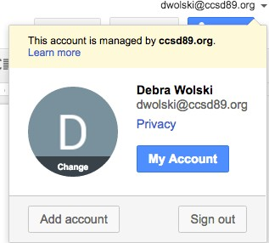
- Log out of Google Classroom by pulling down your email address at the top right and selecting Log Out.

