Grading Scale

**[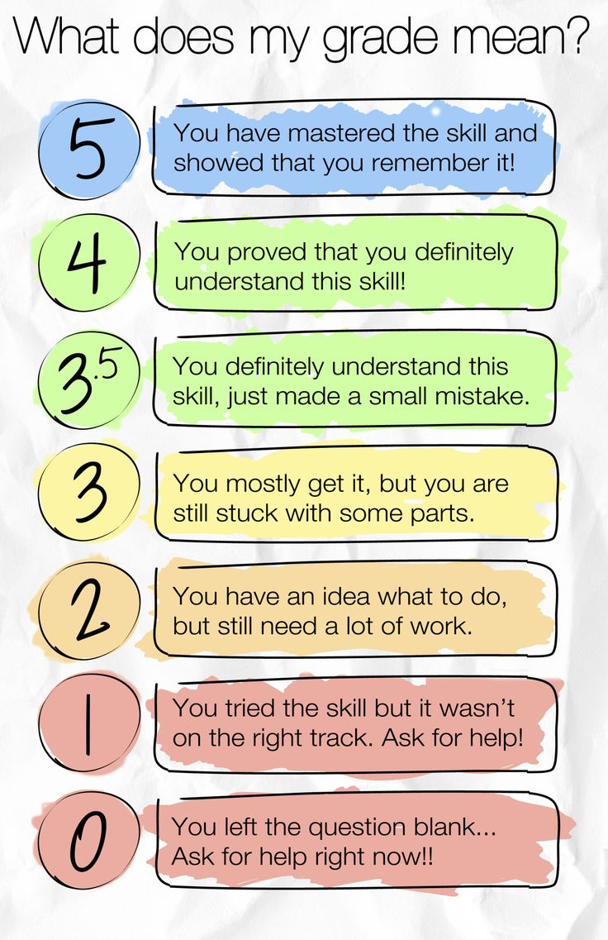](https://app.box.com/embed_widget/s/8z0wguh6n8ktb8v3emxg?theme=blue)**

You have mastered this skill and used it in a way that goes beyond what was taught in class.

**3D**

**3**

**2.5**

**2**

**1.5**

**1**