**Appalachian Plateau**

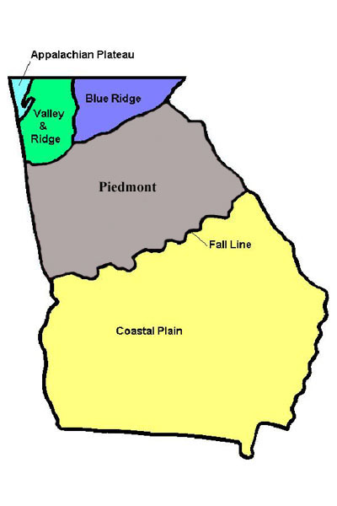

Color the Appalachian Plateau region **red**.

Land: __________________________

______________________________

______________________________

______________________________

Animals: ________________________

______________________________

______________________________

______________________________

Weather: _______________________

______________________________

______________________________

______________________________



Color the Valley and Ridge region **blue**.

Land: __________________________

______________________________

______________________________

______________________________

Animals: ________________________

______________________________

______________________________

______________________________

Weather: _______________________

______________________________

______________________________

______________________________

**Valley and Ridge**

Land: __________________________

______________________________

______________________________

______________________________

Animals: ________________________

______________________________

______________________________

______________________________

Weather: _______________________

______________________________

______________________________

______________________________

Color the Piedmont region **green**.

**Piedmont**

**Blue Ridge Mountains**



Color the Blue Ridge Mountains region **yellow**.

Land: __________________________

______________________________

______________________________

______________________________

Animals: ________________________

______________________________

______________________________

______________________________

Weather: _______________________

______________________________

______________________________

______________________________



**Appalachian Plateau**

**Valley and Ridge**

**Blue Ridge Mountains**

**Piedmont**

**Coastal Plain**

**All About the Five Regions of Georgia:**

**Coastal Plain**



Color the Coastal Plain region **orange**.

Land: __________________________

______________________________

______________________________

______________________________

Animals: ________________________

______________________________

______________________________

______________________________

Weather: _______________________

______________________________

______________________________

______________________________

